**Details of your portfolio**

PD URL site *(*Compulsory to fill up for milestone 2 and 3):*

*Live link/URL of your PD site*

Name of your portfolio:

*Turtle boi*

Your Logo:

*Insert your logo*

Describe your target audience:

*Who they are? Describe the demographics of your audience that matter such as age, nationality, race, geographic location, dis/abilities, income level, education level, gender, and sexuality. Describe the psychographics of your audience that matter such as their values, beliefs, and positions, and background knowledge about your topic.*

*My target audience would be potential employers in the front-end web development workplace. They should be looking out for skills related to web design and development. They typically are based in Singapore or can be from other English-speaking regions. They will possess a higher education level (diploma, degree, or any other relevant qualifications) typically in IT field or other certificates that are relevant to IT. They should have background knowledge in understanding how websites operates. They shall possess values attention to detail, technical expertise, and the ability to adapt to current trends. Usually, their beliefs would be that a good design creates productivity while being easy to maintain and they strive to achieve efficiency in development.*

Describe your brand story/ purpose:

*Write a short summary of yourself. E.g. Who you are, your inspiration to be (graphics designer/developer/etc), something that interest your target audience, etc*

*I am a student who specalises in digital design and development and I aspire to be a front-end web developer that can contribute to development of practical, innovative and visually pleasing websites that meet users needs and requirements.*

*My purpose is to show employers I can merge design and development to create works that stand out and deliver value by ensuring every project done utilises practical skills and that necessary requirements are achieved.*

**Design brief**

Colour scheme & Colour palette:

*Which colour scheme you have selected for your website? Analogues? Complementary? Triadic? Monochromatic? What are the colours in your colour palette?*

*I have decided to a blend of warm colour palette and cool colour palette to form a gradient colour scheme. This help elevates the liveliness for the webpage. Each page will have its own blend of gradient to showcase varying personality.*

Typography:

*What is the fonts type used?*

Theme:

*Minimalistic? Contemporary? Fantasy? Sci-fi?*

Overall, my website theme is designed to be a modern artistic portfolio.

Layout/ Arrangement:

*How will you arrange the multimodal composition in a way that makes sense for your audience and your purpose? How might you arrange ideas and elements so that your composition is effective?*

***Minimally 3 tabs with 2 layers of navigation***

Opening page

Home

About

Contact

Portfolio

Development

All

Design

**Low fidelity wireframe:**

*Insert your low-fidelity wireframe here. This can be photo of your sketches or digitally created low-fidelity wireframe using shapes. E.g.*

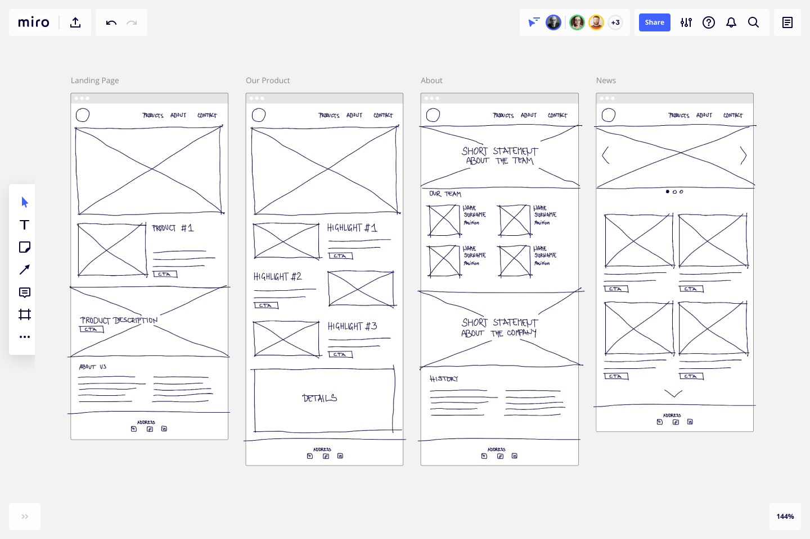

**High fidelity wireframe** *(*Compulsory to fill up for milestone 2 and 3)***:**

*Insert your high-fidelity wireframe here. Full set of ALL the pages in JPEG or PDF format.*

*E.g.*



**Link to your Prototype – Most likely on Figma (make sure your lecturer is given access to the site)** *(To fill up for milestone 2 and 3)***:**

*Insert your Prototype link here (most likely on Figma)*

**Reference sites** *(*Optional)***:**

[**https://docs.google.com/spreadsheets/d/10QoCC0RZwQWDhl6FpnaSRzswBuOEWHAU/edit?gid=1247136888#gid=1247136888**](https://docs.google.com/spreadsheets/d/10QoCC0RZwQWDhl6FpnaSRzswBuOEWHAU/edit?gid=1247136888#gid=1247136888)

**[https://docs.google.com/spreadsheets/d/1XSYn1UK4G5DPmGiPrvWPeFl_whiwY0nM/edit?gid=1247136888#gid=1247136888](#_Hlk202393506" \s "1,2198,2306,0,,https://docs.google.com/spreadsh)**

***Seniors PD works***

***Google images, ChatGPT***